Name: ***Natalia Russu***

Lesson 5: Joins and Unions

1. Join the film to the film_actor table.

**SELECT** film.film_id, film.title, film.description,

film.release_year, film.language_id, film.rental_duration,

film.rental_rate, film.length, film.replacement_cost,

film.rating, film.last_update, film.special_features,

film.fulltext, actor_id

**FROM** film

**FULL JOIN** film_actor

**ON** film.film_id = film_actor.film_id;

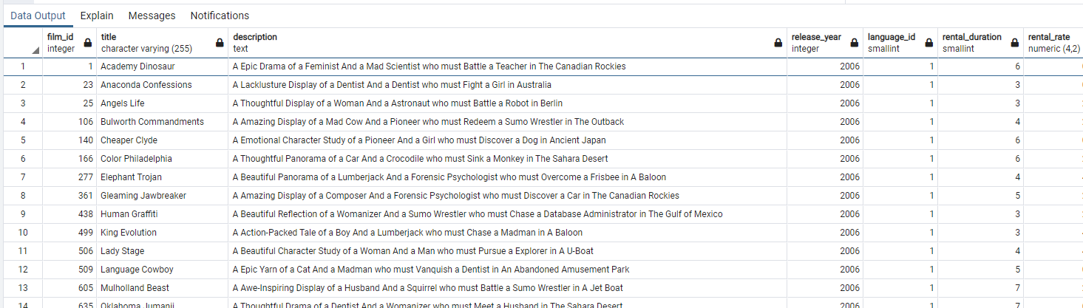

1. Join the actor table to the film_actor table.

SELECT actor.actor_id, actor.first_name, actor.last_name, actor.last_update, film_actor.film_id

from actor

full join film_actor

ON actor.actor_id = film_actor.actor_id;

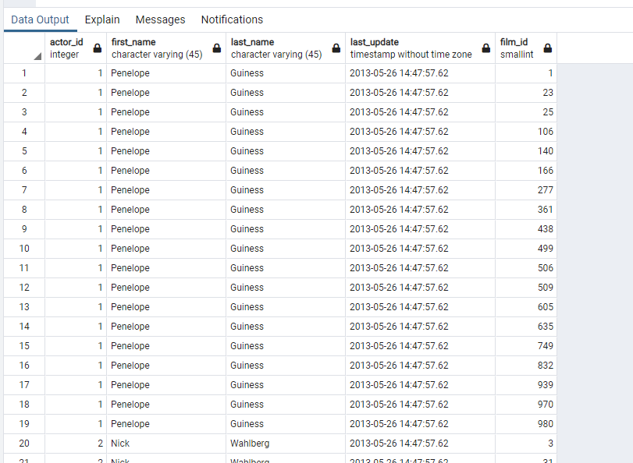

1. Try to join the actor, film_actor, and film table together (3 joins!)

**select** film.film_id, film.title, film.description,

film.release_year, film.language_id, film.rental_duration,

film.rental_rate, film.length, film.replacement_cost,

film.rating, film.last_update, film.special_features,

film.fulltext, film_actor.actor_id, actor.first_name, actor.last_name

f**rom** film **as** film

**FULL JOIN**

film_actor **as** film_actor

**ON** film.film_id = film_actor.film_id

**FULL JOIN**

actor **AS** actor

**ON** film_actor.last_update = actor.last_update

